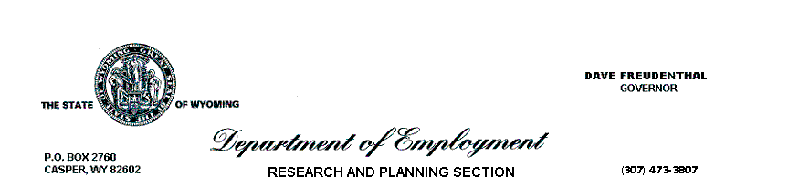
June 11, 2008

Dear:

Research and Planning (R&P) has been asked to assist your department in a study supporting human resource planning. Results of the study will be published in summary, statistical form in Wyoming Labor Force Trends (see http://doe.state.wy.us/LMI/trends.htm). This study is not related to ongoing classification and compensation revisions by the Department of Administration and Information.

Every person’s response contributes to a better understanding of the work environment and circumstances affecting your career choices. All responses count equally. Thus far, 67.5% of your colleagues have responded. R&P asks you to help by completing the enclosed confidential form and returning it in the enclosed self-addressed stamped envelope (for your convenience, form may be faxed to me at 307-473-3806). The form includes questions about your work environment and some of your circumstances that may affect your career decisions. For most of you, the form will take less than 15 minutes to complete.

Your information will be used exclusively for the study of workforce needs. No personally identifiable information will leave R&P. No individual employee or section will be identifiable. Pursuant to the Workforce Investment Act, information collected by R&P may only be used for statistical purposes, (see 29 USC sec. 491-2 (a)(2) at: http://doe.state.wy.us/lmi/section309.htm.) Only two R&P employees will have access to individual employee information for the purpose of studying workforce needs.

To protect the confidentiality of your response, please do not include your name or return mail information on the return envelope.

Please mail or fax your responses by Monday, June 23, 2008. If you have already responded, please disregard this notice. Thank you for your assistance.

Tom Gallagher
Manager, Research & Planning

enclosures

